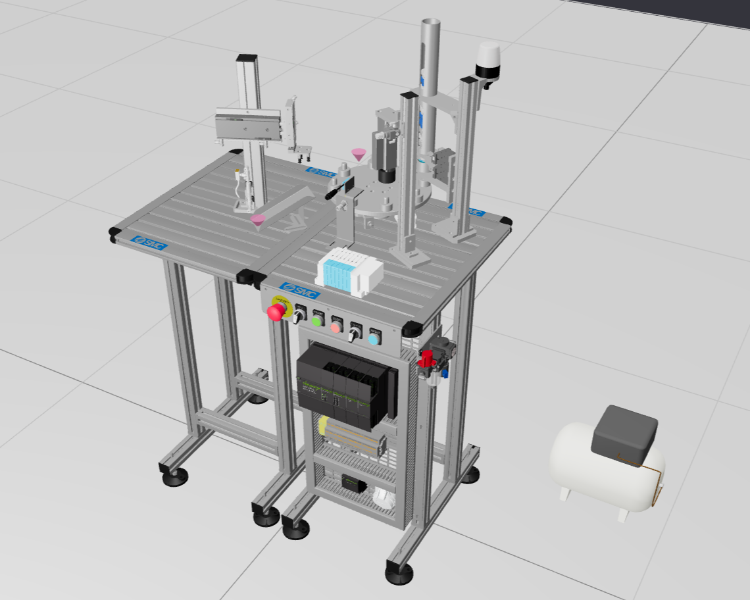
Public System
PLC Challenge: SMC Demo
This is a demo system of one of the training systems available from SMC International Training. The IO list is available as asset in the system
For more training systems checkout: https://www.smctraining.com/en/webpage/indexpage/1837
System description:
The system can be used for sorting of workpiece based on their color and material. Check out the video to understand the fundamental of the system. In this video, the user is operating the system manually.
The system has the following key assemblies with various components:
11_Dispenser
It ejects six different types of workpieces.
- White large (non-metallic)
- White small (non-metallic)
- Blue large (non-metallic)
- Blue small (non-metallic)
- Grey large (metallic)
- Grey small (metallic)
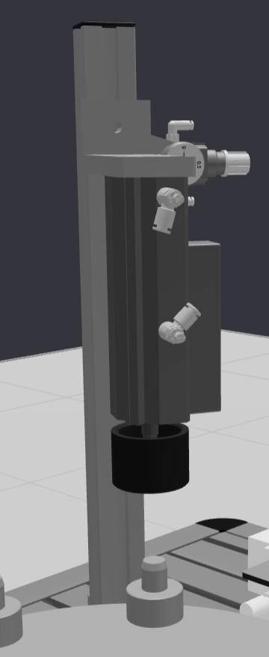
When 'A_2_Actuator' gets TRUE, a workpiece get ejected and placed on the Turntable.
12_Press
The press is used to measure the height of the workpiece. The height is measured by the pneumatic cylinder which gives a analog voltage feedback from 0 ~ 9.2 volts.
This feedback can be used to differentiate larger and smaller workpieces

13_Sensors
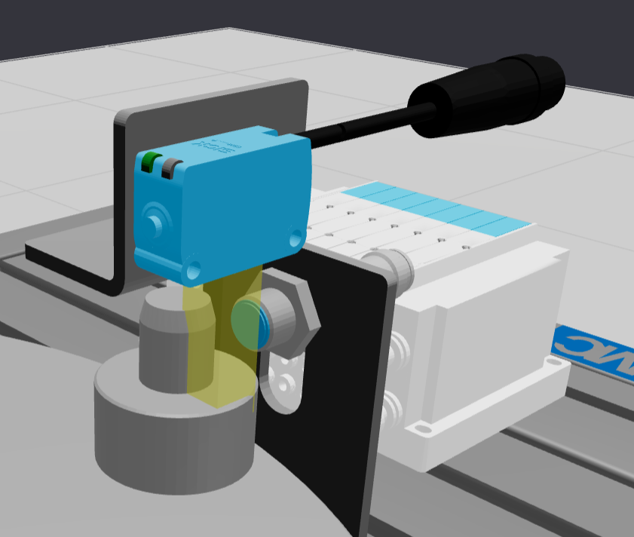
In this unit, the workpiece type can be measured. The following two sensors are used:
- Inductive: To measure metallic objects
- DIffuse: To measure dark colored object (blue workpieces)

14_Turntable
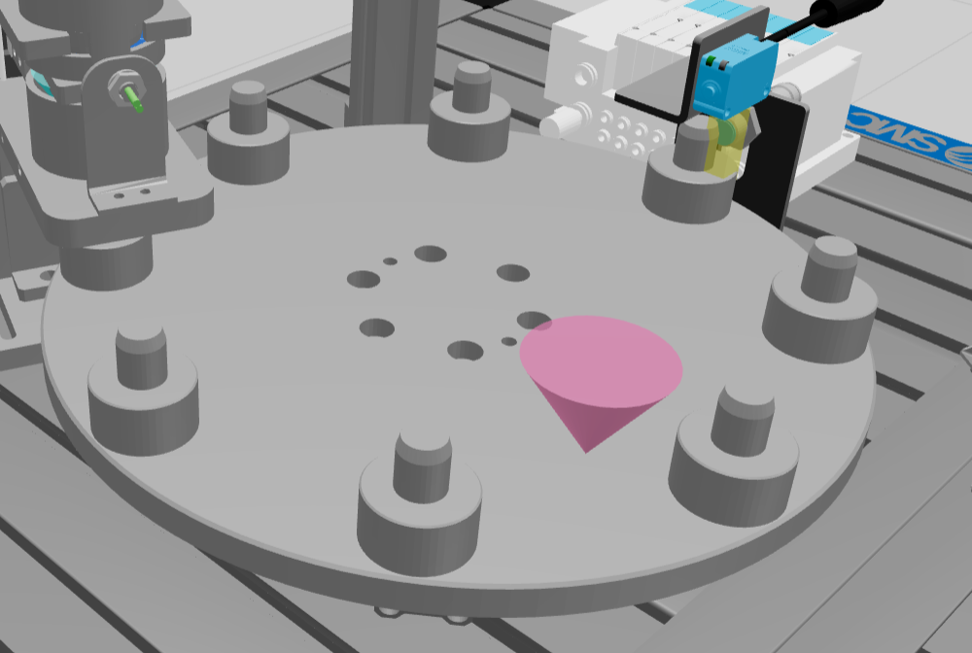
It is used to transfer the workpiece to the next location. To turn the table 'D_Actuator_1' and 'C_Actuator' should be energized in a sequence. And then 'C_Actuator' and 'D_Actuator_1' should be de-energized in a sequence.

15_Evacuation_Manipulator
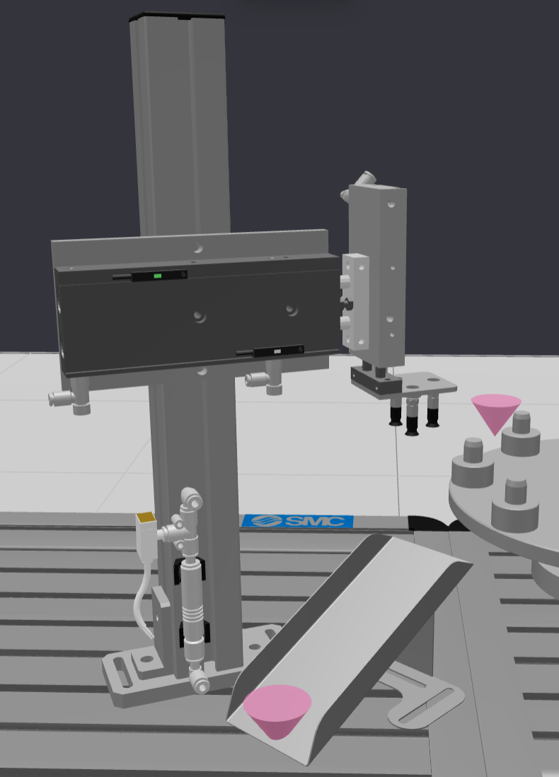
This manipulator is used to pick the object from the turntable and place it on the slide. At the end of slide is a 'z01_Lid_Exit' to remove the workpieces from the workspace.

04_Estructure_And_ButtonPanel
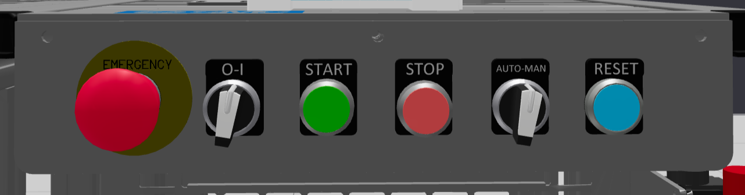
This panel can be used to give signals to the PLC for operation control
03_ElectricSupply
The system has electric supply of 24VDC and 3 phase voltage. In this unit, the power has been distributed to all the electric component. To understand more about the wiring of the system, kindly study the 2D diagram.
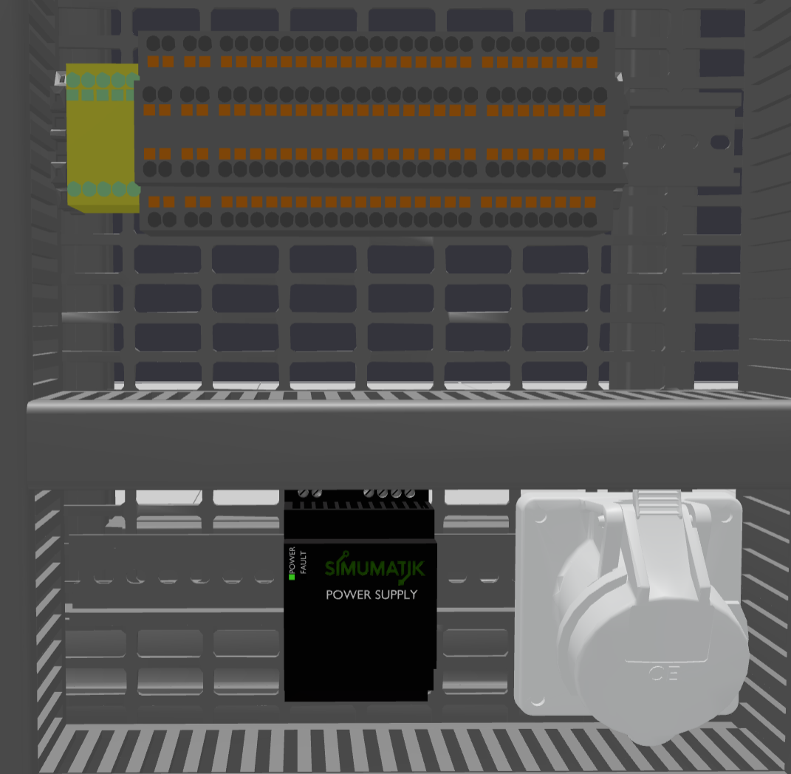
01_PLC
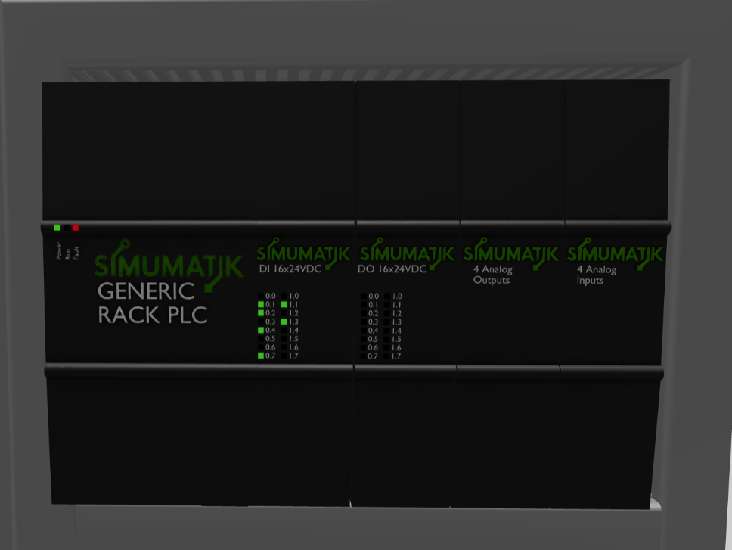
The system is equipped with Simumatik Generic Rack PLC. You can use any PLC of your choice to program the system.
02_AirSupply
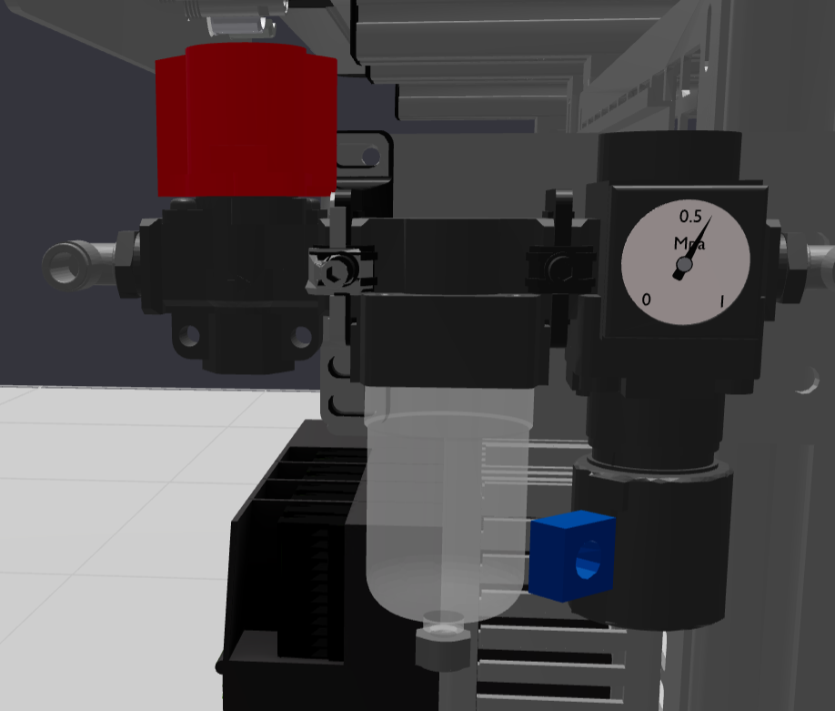
The pneumatic supply can be controlled using the Air Supply unit. The default pneumatic pressure is set to 6 bar in the system.
Exercise:
This system can be used for sorting application. Create an automatic sequence with recipe to fulfil the below tasks:
- Task 1: Sorting metallic objects: Create an automatic sequence such that the Evacuation manipulator only pick the metallic objects from the turntable and place it on the slide.
- Task 2: Sorting non-metallic objects: Create an automatic sequence such that the Evacuation manipulator only pick the non-metallic objects from the turntable and place it on the slide.
- Task 3: Sorting large blue objects: Create an automatic sequence such that the Evacuation manipulator only pick the large blue objects from the turntable and place it on the slide.
- Task 4: Sorting small blue objects: Create an automatic sequence such that the Evacuation manipulator only pick the large blue objects from the turntable and place it on the slide.
- Task 5: Sorting large metallic objects: Create an automatic sequence such that the Evacuation manipulator only pick the large metallic objects from the turntable and place it on the slide.
- Task 6: Sorting small metallic objects: Create an automatic sequence such that the Evacuation manipulator only pick the small metallic objects from the turntable and place it on the slide.
- Task 7: Sorting small white objects: Create an automatic sequence such that the Evacuation manipulator only pick the small white objects from the turntable and place it on the slide.
- Task 8: Sorting large white objects: Create an automatic sequence such that the Evacuation manipulator only pick the large white objects from the turntable and place it on the slide.

